[[1]](" \l "8cjcjqx5pymg)  **Data Driven Innovations in Supply Chain Management With Qlik Insights**

S*ubmitted by - Taru Namdeo*

**1.**   **INTRODUCTION**

**1.1 OVERVIEW**

This report titled "Data Driven Innovations in Supply Chain Management Using Qlik Insights" explores the transformative impact of advanced data analytics on supply chain operations, emphasizing the role of Qlik's powerful data visualization and business intelligence tools. It begins by discussing the current challenges in supply chain management and the significance of data analytics, followed by an introduction to Qlik's capabilities. The report highlights Qlik’s role in integrating with existing systems for real-time analytics and showcases case studies of successful implementations leading to innovations in demand forecasting, inventory management, and logistics optimization. It provides a detailed guide on implementing Qlik, best practices for data handling, and strategies to overcome common challenges. Additionally, it explores emerging trends and future applications of data analytics in the supply chain. Concluding with a call to action, the report underscores the importance of embracing data-driven approaches to achieve efficiency, cost reduction, and enhanced customer satisfaction.

**1.2 PURPOSE**

The purpose of the project is to provide a comprehensive and detailed exploration of how advanced data analytics, enabled by Qlik’s sophisticated data visualization and business intelligence tools, can transform supply chain management. This report aims to serve as an educational and practical guide for supply chain professionals, business leaders, and decision-makers, highlighting the strategic importance of adopting data-driven approaches in today's competitive business environment.

By delving into the capabilities of Qlik, the project illustrates how organizations can integrate these tools with existing supply chain systems to achieve real-time analytics and gain actionable insights. It presents a series of real-world case studies that showcase successful implementations of Qlik, demonstrating tangible improvements in areas such as demand forecasting, inventory management, logistics optimization, and overall operational efficiency. Ultimately, the report aims to empower organizations to harness the full potential of data-driven decision-making, leading to significant benefits such as cost reduction, enhanced efficiency, and improved customer satisfaction. It serves as a call to action for businesses to embrace innovation through Qlik insights, ensuring they remain competitive and agile in the ever-changing market.

**1.3 TECHNICAL ARCHITECTURE**

The technical architecture of this project, as illustrated by the Qlik Analytics Services dashboard, integrates various datasets and utilizes Qlik's powerful analytics tools to provide comprehensive insights into the supply chain management processes.

**Components of the Architecture**

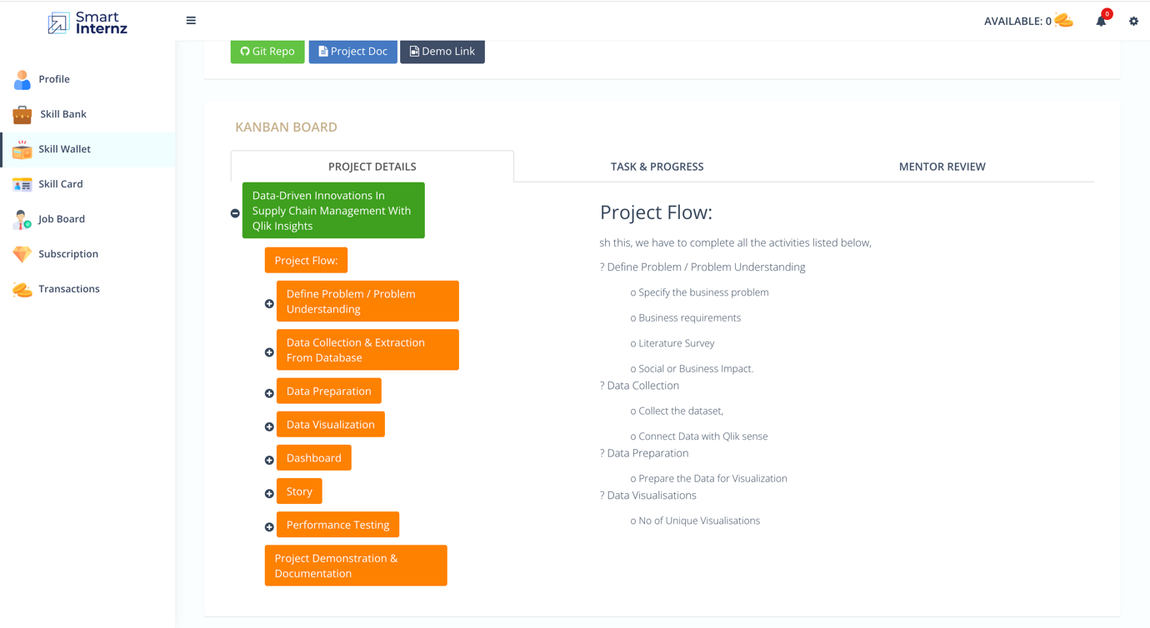

**1. Problem Definition**

* **Specify the Business Problem**: Identify specific supply chain inefficiencies or challenges.
* **Business Requirements**: Determine the necessary data and analytics capabilities.
* **Literature Survey**: Review existing research and case studies.
* **Social or Business Impact**: Evaluate the potential impact on operations and stakeholders.

**2. Data Collection & Extraction**

* **Collect the Dataset**: Gather data from various supply chain sources, including suppliers, transportation providers, and warehouses.
* **Connect Data with Qlik Sense**: Integrate and consolidate data into the Qlik Sense environment for analysis.

**3. Data Preparation**

* **Prepare the Data for Visualization**: Clean, preprocess, and structure the data to ensure it is ready for analysis and visualization in Qlik Sense.

**4. Data Visualization**

* **Number of Unique Visualizations**: Create multiple visualizations to represent different aspects of the supply chain, including performance metrics, logistics data, and real-time tracking.

**5. Dashboard Creation**

* **Dynamic Dashboards**: Develop interactive and intuitive dashboards using Qlik Sense to provide stakeholders with comprehensive insights into the supply chain.

**6. Storytelling**

* **Story**: Use Qlik Sense storytelling features to create narrative-driven presentations that highlight key insights and findings from the data analysis.

**7. Performance Testing**

* **Performance Testing**: Ensure that the dashboards and visualizations are optimized for performance, scalability, and responsiveness.

**8. Project Demonstration & Documentation**

* **Demonstration**: Showcase the developed dashboards and insights to stakeholders.
* **Documentation**: Provide thorough documentation of the data integration, preparation, visualization, and analysis processes, including technical details and user guides.

By leveraging the capabilities of Qlik Analytics Services, this project integrates multiple data sources into a centralized platform, providing powerful tools for data analysis and visualization. This architecture supports the optimization of supply chain management, improving operational efficiency, reducing costs, and enhancing customer satisfaction. The use of Qlik's advanced features ensures that stakeholders have access to real-time, actionable insights that drive informed decision-making across the organization.

**2.**   **PROBLEM UNDERSTANDING**

**2.1 SPECIFICATIONS OF THE BUSINESS PROBLEM**

DataCo Global, a retail company, possesses extensive data covering the entire lifecycle of its products, from preparation to sale. This wealth of data holds the potential to provide valuable insights that can optimize inventory management, enhance product offerings, improve supply chain efficiency, personalize customer experiences, and support data-driven decision-making. Despite this, DataCo Global struggles to fully capitalize on its data to drive these benefits.

Key challenges include:

1. **Fragmented Data**: The data is siloed across different systems, making it difficult to achieve a comprehensive view and extract actionable insights.
2. **Underutilization of Data**: There is an inefficiency in leveraging the available data to its full potential, leading to missed opportunities for operational improvements.
3. **Supply Chain Inefficiencies**: Existing supply chain processes are not optimized, resulting in higher costs and slower response times.
4. **Customer Experience**: The current approach does not effectively utilize data to personalize and enhance customer experiences.
5. **Decision-Making**: Organizational decision-making lacks the depth and accuracy that could be achieved through comprehensive data analysis.

This project aims to address these issues by using Qlik's data analytics and visualization tools to integrate and analyse DataCo Global's data. The project will focus on:

* Enhancing the efficiency of data management and utilization.
* Optimizing global supply chain operations.
* Improving customer satisfaction through better personalization.
* Supporting informed and strategic decision-making across the organization.

By addressing these challenges, the project seeks to transform DataCo Global's data into a strategic asset, driving operational efficiency, enhancing customer experiences, and providing a competitive advantage in the market.

**2.2 BUSINESS REQUIREMENTS**

To address these challenges, the project will implement a robust data integration strategy to aggregate and centralize relevant data from diverse supply chain sources. By utilizing Qlik's advanced visualization capabilities, the project will create intuitive and dynamic dashboards that provide stakeholders with clear insights into the entire supply chain ecosystem. These dashboards will facilitate better understanding and monitoring of key performance indicators across the supply chain.

1. **Robust Data Integration**:

* Centralize data from various supply chain sources using a comprehensive data integration framework.

1. **Advanced Visualization**:

* Utilize Qlik's tools to create dynamic dashboards for clear insights into supply chain operations.

1. **Historical Data Analysis**:

* Analyse historical logistics data with Qlik's analytics to optimize transportation routes and reduce costs.

1. **Real-Time Analytics**:

* Set up real-time analytics and alert systems to enable quick decision-making during disruptions or demand changes.

These requirements aim to create an integrated, transparent, and responsive supply chain, enhancing operations and performance through Qlik's advanced tools.

Furthermore, Qlik's advanced analytics features will be leveraged to analyze logistics data, identify patterns, and optimize transportation routes. This will lead to more efficient and cost-effective transportation management. Additionally, real-time tracking and monitoring solutions will enhance visibility into the movement of goods, reducing lead times and minimizing transportation costs.

To ensure a proactive and responsive supply chain, the project will also implement real-time analytics to facilitate quick decision-making in response to unforeseen events or changes in demand. This will enable DataCo Global to react promptly and effectively, ensuring continuity and efficiency in supply chain operations.

Overall, by addressing these challenges through the integration of Qlik's tools and advanced analytics, DataCo Global aims to transform its data into a strategic asset. This transformation will drive operational efficiency, enhance customer experiences, and provide a competitive advantage in the market.

**2.3 LITERATURE SURVEY**

The "DataCo Smart Supply Chain for Big Data Analysis" dataset on [Kaggle](https://www.kaggle.com/datasets/shashwatwork/dataco-smart-supply-chain-for-big-data-analysis/data) provides a valuable resource for analyzing various aspects of supply chain management. This dataset facilitates the application of big data analytics to optimize inventory management, enhance product offerings, improve supply chain efficiency, and drive data-driven decision-making. Key aspects of utilizing this dataset include the integration and centralization of data from diverse sources to provide a holistic view of the supply chain, the use of Qlik’s advanced visualization capabilities to create dynamic dashboards for monitoring operations, and the analysis of historical logistics data to identify patterns and optimize transportation routes.

The Qlik platform is a powerful tool for data analytics and visualization, offering advanced capabilities that can significantly enhance supply chain management. Qlik Sense and QlikView, two of the platform's primary tools, allow for the creation of intuitive and dynamic dashboards that provide clear and actionable insights into the entire supply chain ecosystem. These tools support the integration and centralization of data from various sources, enabling a comprehensive view of operations. Qlik’s associative data engine facilitates the exploration of data relationships, uncovering hidden insights and patterns that might be missed with traditional linear analysis. Additionally, Qlik’s advanced analytics features, including real-time data processing and predictive analytics, enable businesses to make informed decisions quickly and respond proactively to changes in the supply chain. The platform’s ability to handle large volumes of data and its user-friendly interface make it an invaluable asset for driving efficiency, enhancing customer satisfaction, and supporting strategic decision-making

Combining the capabilities of the Qlik platform with the rich data provided by the DataCo Smart Supply Chain dataset can lead to transformative improvements in supply chain operations. This synergy allows businesses to leverage data-driven insights for optimizing inventory management, streamlining logistics, and personalizing customer experiences, ultimately gaining a competitive edge in the market.

**3.**   **DATA COLLECTION**

**3.1 COLLECTION OF DATASET**

Data collection for the "DataCo Smart Supply Chain for Big Data Analysis" involves gathering a wide array of data from various sources that span the entire supply chain process. This comprehensive dataset includes multiple facets of supply chain operations, which are crucial for performing in-depth analysis and deriving actionable insights.

**Specific Datasets Provided**

* **DataCoSupplyChainDataset.csv**: This file contains a comprehensive set of data points covering various aspects of supply chain management, such as order processing, inventory management, and logistics. It is structured to provide detailed insights into the operational efficiency and performance metrics across the supply chain. [Dataset link](https://drive.google.com/file/d/1QbokfGj-8G1K7QRmbK4eQcvtbZO9ribl/view?usp=drive_link).
* **tokenized_access_logs.csv**: This dataset includes logs of user interactions and access patterns, which can be analyzed to understand how different stakeholders interact with the supply chain systems. It provides insights into user behaviour and system usage, which are essential for optimizing user interfaces and improving system performance.

[Dataset link.](https://drive.google.com/file/d/1DNl-FdfZjs3BRuaK-Q-vVC6lj6Tnhxye/view?usp=drive_link)

**Data Collection Methodology**

1. **Automated Data Collection**: Integration with ERP, WMS, and TMS systems to automatically collect and update data in real-time. This ensures that the dataset is current and reflects the latest operational status.
2. **IoT Integration**: Utilizing IoT devices to collect real-time data on the condition and location of goods. This data is crucial for monitoring the supply chain in real-time and making quick decisions.
3. **Manual Data Entry**: In cases where automated collection is not feasible, manual entry of data by supply chain personnel. This includes data from physical inspections and audits.
4. **Data Cleaning and Validation**: Collected data is cleaned and validated to ensure accuracy and reliability. This step involves removing duplicates, correcting errors, and filling in missing values.
5. **Data Aggregation**: Aggregating data from multiple sources into a centralized data repository. This step is crucial for creating a comprehensive view of the supply chain and enabling advanced analytics.

**3.2 CONNECTING DATA WITH QLIK SENSE**

To connect the provided datasets in Qlik Sense, follow these step-by-step instructions:

**1. Log in to Qlik Sense**

* Open your web browser and go to the Qlik Sense URL (e.g., anek422cnludpg6.sg.qlikcloud.com).
* Log in with your credentials.

**2. Create a New App**

* Click on the green **“Add new”** button at the top right of the screen.
* Select **“Create new app”**.
* Enter a name for your app (e.g., "Supply Chain Management Analysis") and click **“Create”**.
* Once the app is created, click **“Open app”**.

**3. Add Data**

* In the newly opened app, click **“Add data”**.
* Choose the method to add data. For CSV files, select **“Data files”**.

**4. Upload Data Files**

* Click on **“Select file”** and navigate to where your datasets (DataCoSupplyChainDataset.csv and tokenized_access_logs.csv) are stored.
* Select each file and upload them one by one.
* After uploading, Qlik Sense will preview the data. Click **“Next”**.

**5. Data Preparation**

* Qlik Sense will guide you through the process of loading data.
* You can inspect and transform the data here if needed. Ensure the data types (e.g., text, number, date) are correctly recognized.
* Click **“Load data”** once you are satisfied with the preview.

**6. Data Manager**

* After loading, you will be taken to the **Data manager**.
* Here, you can see the associations Qlik Sense has automatically made between tables based on field names. Ensure that the relationships (keys) between tables are correct.
* If you need to create or modify associations, you can do so by dragging and dropping fields between tables.

**7. Data Model Viewer**

* Navigate to the **Data model viewer** by clicking on the **“Data”** icon on the left and Charger selecting **“Data model viewer”**.
* Inspect the data model to ensure all connections (associations) are correct. Modify as needed by clicking on the lines connecting the tables and adjusting the fields.

**4.**   **DATA PREPARATION**

**4.1 PREPARING THE DATA FOR VISUALISATION**

Data preparation in Qlik Sense involves several steps to ensure that your data is clean, properly formatted, and ready for analysis. Here’s an in-depth look at the process:

**1. Loading Data**

* **Data Sources**: Qlik Sense allows you to load data from various sources such as CSV files, Excel files, databases, web files, and other applications.
* **Data Loading Options**: You can load data directly through the Data Manager or use the Data Load Editor for more complex data loading and scripting needs.

**2. Data Profiling**

* **Data Preview**: When you upload a dataset, Qlik Sense provides a preview of the data. This helps in understanding the structure, types of data, and identifying any immediate issues.
* **Field Recognition**: Qlik Sense automatically recognizes fields and their data types (e.g., string, number, date). Ensure these are correctly identified as this impacts data manipulation and analysis.

**3. Data Cleansing**

* **Handling Missing Values**: Identify and handle missing values. This could involve filling in missing data, removing rows/columns, or imputing values based on other data.
* **Removing Duplicates**: Check for and remove duplicate records to maintain data integrity.
* **Data Formatting**: Ensure consistency in data formats, such as date formats or numerical precision.

**4. Data Transformation**

* **Field Renaming**: Rename fields for better clarity and to maintain consistency across datasets.
* **Creating New Fields**: Use Qlik Sense’s expression editor to create new calculated fields that can provide additional insights.
* **Data Aggregation**: Aggregate data to summarize information at the desired level (e.g., daily, monthly sales data).

**5. Data Associations**

* **Automatic Associations**: Qlik Sense automatically creates associations between tables based on common field names. Verify these associations to ensure they reflect the correct relationships.
* **Manual Associations**: If necessary, manually define relationships between tables using key fields to ensure the data model is accurate.
* **Table Concatenation**: Concatenate tables when dealing with similar data structures to create a unified dataset.

**6. Data Quality Checks**

* **Consistency Checks**: Ensure data consistency across different datasets. This involves verifying that data values are logically consistent.
* **Integrity Checks**: Validate the integrity of data by ensuring that the relationships between different tables are correct and complete.

**7. Data Loading Script**

* **Scripting**: Use the Data Load Editor to write custom scripts for data loading and transformation. This is useful for complex data manipulations that cannot be handled through the GUI.
* **Incremental Load**: Implement incremental loading to update only the changed data rather than reloading entire datasets, improving efficiency.

**8. Data Reload**

* **Scheduled Reloads**: Set up scheduled data reloads to ensure your data is up-to-date. This is crucial for real-time analytics and reporting.
* **Manual Reloads**: Perform manual data reloads when needed, especially after significant changes to the data structure or content.

**9. Data Validation**

* **Field and Table Validation**: Validate the fields and tables after loading to ensure all data has been correctly imported and transformed.
* **Test Visualizations**: Create test visualizations to verify that the data behaves as expected. This helps in identifying any anomalies or issues early.

**5.**   **DATA VISUALIZATION**

**5.1 VISUALISATIONS**

Data visualization is the process of creating graphical representations of data to help people understand and explore the information. The goal of data visualization is to make complex data sets more accessible, intuitive, and easier to interpret. By using visual elements such as charts, graphs, and maps, data visualizations can help people quickly identify patterns, trends, and outliers in the data.

There are a  number of unique visualizations that can be created with a given dataset. Some common types of visualizations that can be used to analyse the performance and efficiency of a company include bar charts, line charts, heat maps, scatter plots, piecharts, tree Maps etc. These visualizations can be used to compare performance, track changes over time, show distribution, and relationships between variables, breakdown of revenue and customer demographics, workload, resource allocation and location of banks.

Here are some specific examples of data visualizations used in the Qlik dashboards:

* **Sales Overview:** The KPI (Key Performance Indicator) summarizes sales, delivery risk, profit margin, and global profit ratios.

* **Order Country Analysis:** The following Line chart represent sales figures and customer locations, highlighting top countries. There could also be a visualization depicting items ordered by customers in different countries.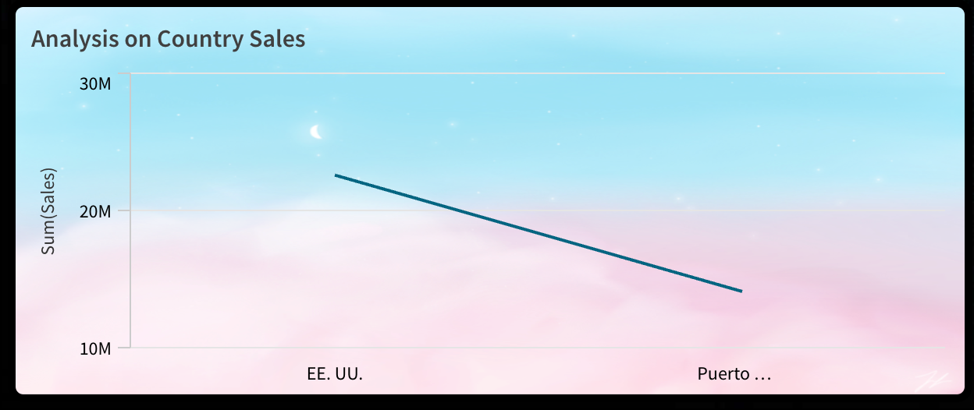

* **Sales by Category:** A Tree map could analyse sales across various product categories. A treemap is a data visualization technique used to display hierarchical data using nested rectangles. Each branch of the hierarchy is represented as a rectangle, which is then subdivided into smaller rectangles representing sub-branches. The size of each rectangle is proportional to a specific data dimension, usually a quantitative variable.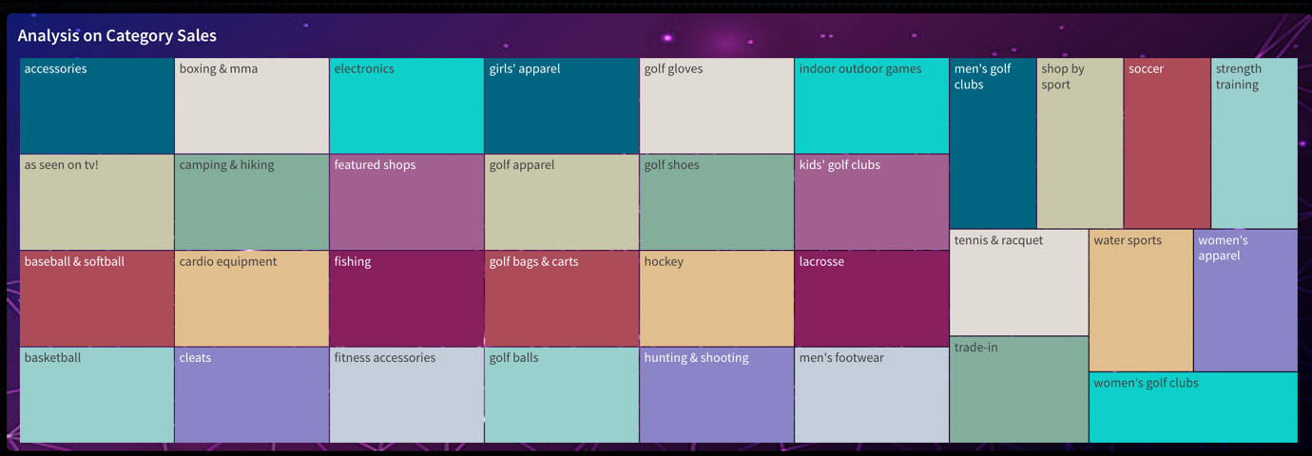

* **Customer Analysis:** The following vertical bar char visualization examine customer segments and their preferred payment methods. It could also explore purchase

behaviour by city and country.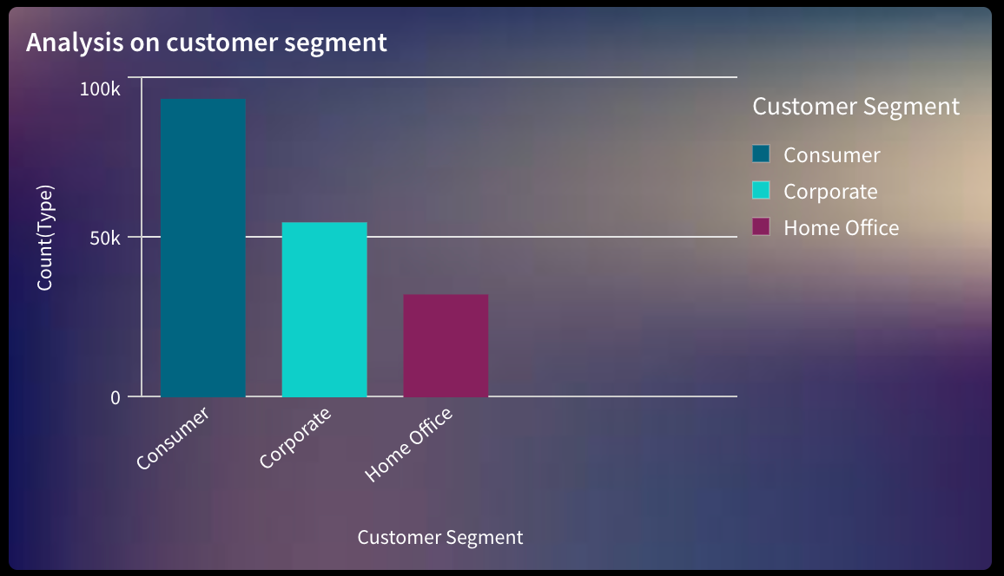

* **Market Analysis:** The chart could provide insights into market performance across different regions. It also likely analyzes order benefits, delivery status, and profit ratios.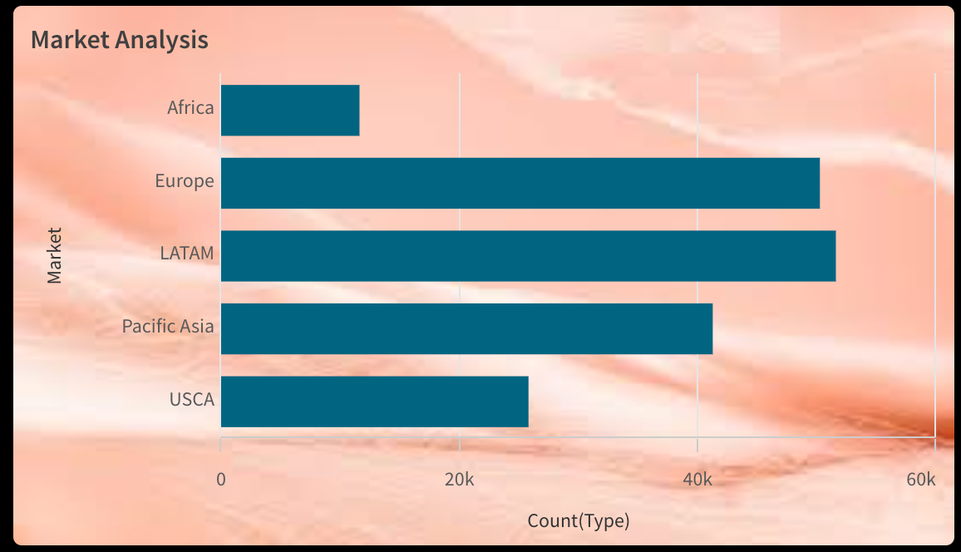

* **Customer Order Analysis:** The following horizontal bar chart explores details such as Customer purchases or Count of orders in a city.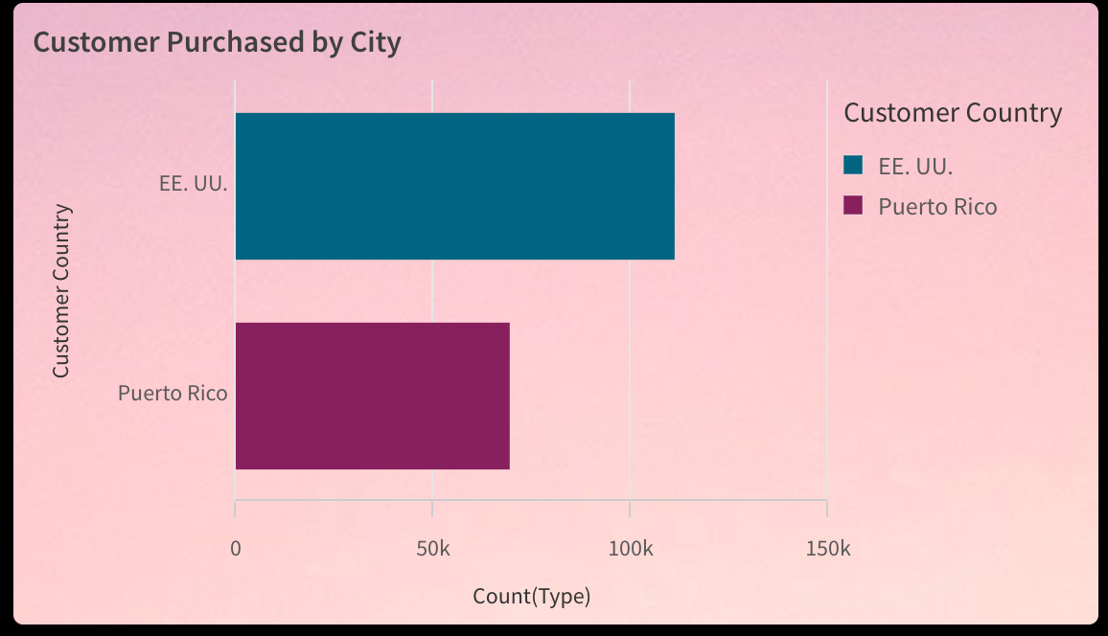

* **Filters:** Filters are a powerful tool in data analysis that allow you to temporarily narrow down a large dataset based on specific criteria For instance, Country(China, USA, Qatar, Australia, etc.), Cities(New York, London, Amsterdam, New Delhi, Dubai etc.).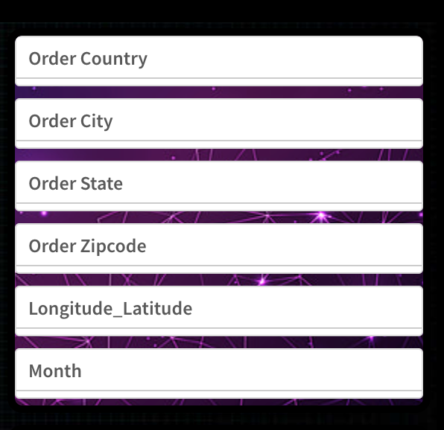

**6.**   **DASHBOARDS**

**4.1 RESPONSIVE DESIGN OF DASHBOARDS**

A dashboard is a graphical user interface (GUI) that displays information and data in an  organized, easy-to-read format. Dashboards are often used to provide real-time monitoring  and analysis of data and are typically designed for a specific purpose or use case.  Dashboards can be used in a variety of settings, such as business, finance, manufacturing,  healthcare, and many other industries. They can be used to track key performance indicators  (KPIs), monitor performance metrics, and display data in the form of charts, graphs, and  tables.

There are Total four dashboards in this project Which have been summarised below-

**Dashboard 1 :**

The first dashboard contains Total of 9 Data visualisation Including KPIs, pie, charts, doughnut charts, Bar charts and filtered pane.

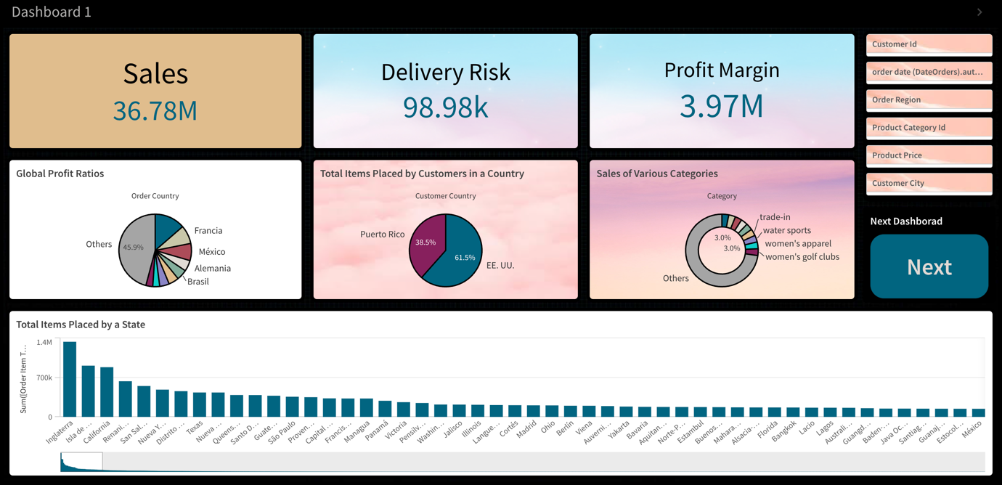

* The first visualisation Is a KPI(Key Performance Indicator) representing the sum of sales for collectively all countries.
* The second visualisation is another KPI, which calculate is the total sum of risk rates in all the countries.
* The third visualisation represents the sum of profit margin in all the countries.
* The fourth visualisation is a pie chart showcasing the global profit ratio among different countries.
* The fifth Visualisation is also a pie chart representing the total items(or orders) placed by customers in a country.
* The sixth visualisation is a doughnut chart representing the sales of various categories such as water, sports, women, golf clubs, etc.
* The seventh Data visualisation is a bar chart representing the total items (orders) placed by a state.
* There is also filter pane to filter out the data according to customer ID, order date, order region, product category ID, product price and customer city.
* There is also a button to navigate to the next dashboard.

**Dashboard 2 :**

Second dashboard contains a total of six Types of data visualisation, including two horizontal bar charts, two vertical bar charts, A filter pane and two buttons.

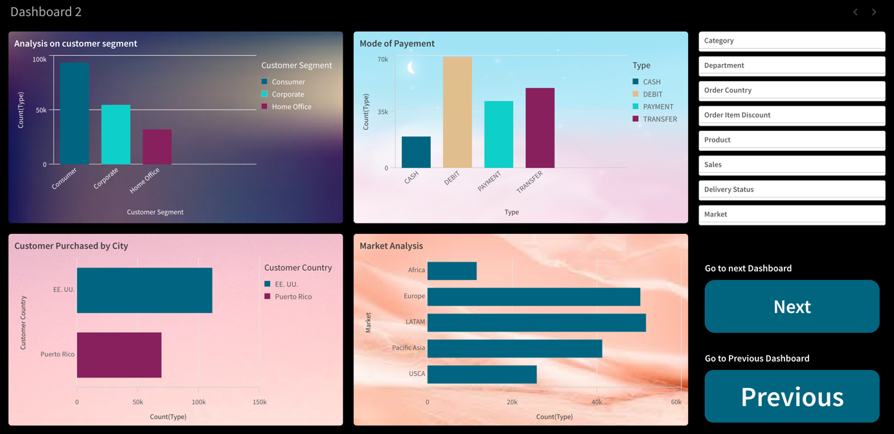

* The first visualisation is a Vertical bar chart representing the The type count of different customer segments.
* The second visualisation is also also a Vertical bar chart representing the type count of different  modes of payment (Cash, debit card, transfer etc).
* The third visualisation is a horizontal bar chart Which represents the analysis on customer purchase by city per type count.
* The fourth visualisation of a horizontal bar chart analyses the market with respect to the type count.
* The dashboard consist of a filter pane Which can be utilised to filter out the useful data on the basis of category, department, order, country, discount, product, sales, delivery, status and market.
* There are two buttons as well to navigate to the previous or the next dashboard.

**Dashboard 3 :**

The third Dashboard consist of six Data visualisation Including A scatterplot, two Vertical bar charts, a line chart, two Buttons and a filter pane. Their descriptions are as follows:

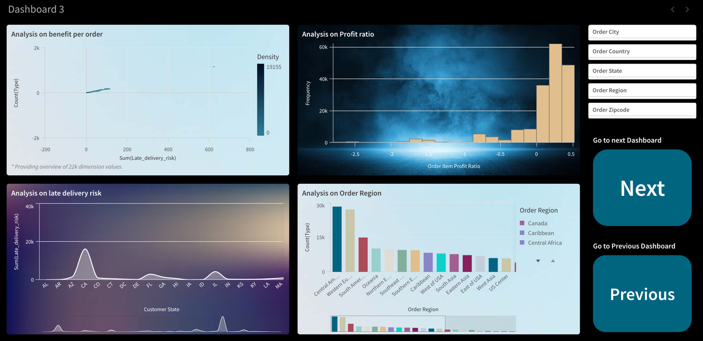

* The first was visualisation represents the analysis on benefits per order. It is a scatterplot of late delivery risk With respect to the count type for different countries.
* The second visualisation in this dashboard is a bar chart drawn between the Profit ratio and frequency representing the trends on profit ratios.
* The third visualisation is a line chart for analysing late delivery risk In different states.
* The fourth visualisation analyses the order region with respect to the count type.
* The dashboard also consist of a filter pane and two buttons for navigation between the other dashboard.

**Dashboard 4 :**

Dashboard consist of five visualisations, including a Tree map, a line chart, a bar chart, a filter, pane and a button. The descriptions of the visualisations are as follows:

* The first visualisation is a tree map analysing various category sales. For example, accessories, electronics, women's apparel, et cetera.
* The second visualisation is a line chart for the analysis of the sum of sales in various countries.

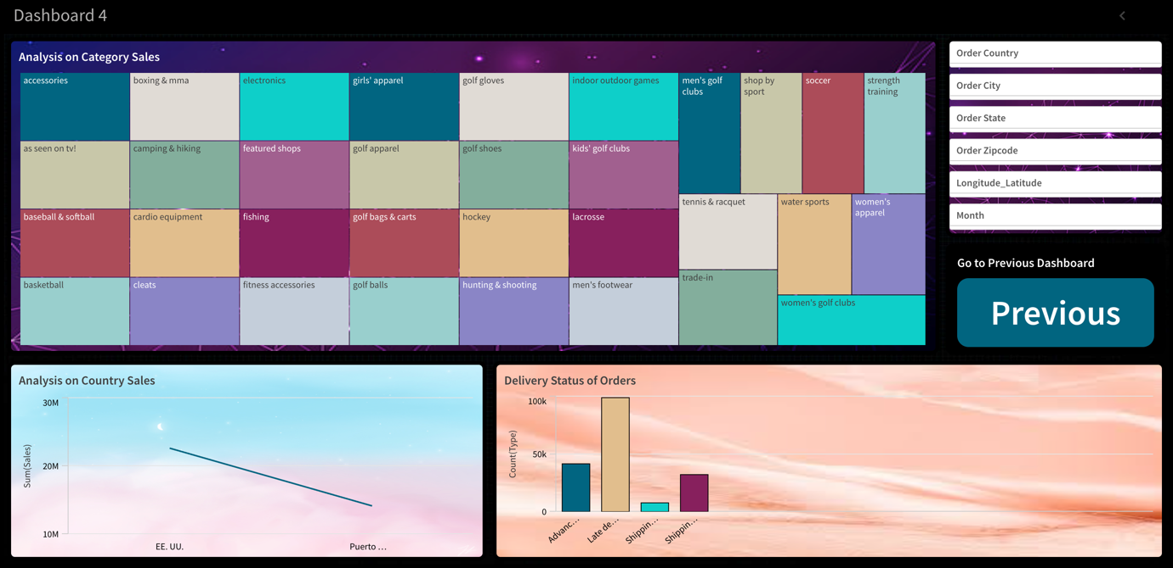

* The third visualisation is a vertical bar chart analysing the delivery status of orders with respect to type count.
* The dashboard also contains a filter pane and a button to navigate towards the previous dashboard.

**7.**   **REPORT**

A report in Qlik sense Is showcased in the form of story. The representation of a story is known as storytelling. A data story is a way of presenting data and analysis in a narrative format, with the goal of making the information more engaging and easier to understand. A data story typically includes a clear introduction that sets the stage and explains the context for the data, a body that presents the data and analysis in a logical and systematic way, and a conclusion that summarizes the key findings and highlights their implications. Data stories can be told using a variety of mediums, such as reports, presentations, interactive visualizations, and videos. [Click Here to view the storytelling.](https://drive.google.com/file/d/1mLOATwkOF20rVBrIqD0P9FEZC3bj2m-K/view?usp=sharing)

**7.1 REPORT CREATION**

Storytelling in Qlik Sense transforms static data into compelling narratives that effectively communicate insights. By following these steps, you can create engaging and informative stories that highlight key findings and support data-driven decision-making.

**1. Prepare Your Data and Visualizations**

Before you begin with storytelling, ensure that you have your data loaded and visualizations ready in Qlik Sense. Create various charts, tables, and graphs that represent the insights you want to present.

**2. Create a New Story**

* **Open Your App**: Navigate to the Qlik Sense app that contains your prepared visualizations.
* **Go to the Storytelling Section**: Click on the **“Storytelling”** icon (a presentation icon) in the left-hand menu.
* **Create New Story**: Click on **“Create new story”**. Give your story a meaningful name and click **“Create”**.

**3. Add Snapshots to Your Story**

Snapshots are static images of your visualizations that you can use in your story.

* **Capture Snapshots**:
  + Open the sheet that contains the visualization you want to add to your story.
  + Click on the visualization to select it.
  + Click on the camera icon that appears (this is the snapshot button).
  + Give your snapshot a name and save it.
* **Add Snapshots to Story**:
  + Go back to the storytelling section and open your story.
  + Drag and drop the snapshots you created from the snapshot library on the right side of the screen to your story.

**4. Create Slides**

Slides in Qlik Sense stories work similarly to slides in any presentation software.

* **Add a Slide**: Click on **“Add new slide”**. This will create a blank slide in your story.
* **Add Content to Slides**:
  + - Drag and drop snapshots, text, shapes, and other media to your slide.
    - You can add multiple snapshots to compare different visualizations.
    - Add titles, descriptions, and annotations to provide context and explanations for each snapshot.

**5. Enhance with Additional Content**

* **Add Text and Images**: Use the text and image widgets to add additional explanations, images, or graphics to your slides.
* **Shapes and Objects**: Use shapes and lines to highlight important areas of your visualizations or to connect ideas.

**6. Linking Slides and Data**

* **Linking to Live Data**: You can link slides to live data so that viewers can see real-time updates. This is useful for interactive presentations.
* **Add Actions**: Set actions on your slides such as navigating to specific sheets or applying filters when a slide is viewed.

**7. Narrate Your Story**

* **Voice Narration**: If desired, you can add voice narration to your story slides to guide viewers through the data.
* **Text Narration**: Write detailed captions or notes to explain the insights shown in each slide.

**8. Preview and Edit Your Story**

* **Preview Mode**: Click on **“Preview”** to see how your story will look during a presentation.
* **Edit Slides**: You can go back and edit any slide to make adjustments based on the preview.

**9. Present Your Story**

* **Presentation Mode**: When your story is complete, click on **“Present”** to enter presentation mode.
* **Navigate Slides**: Use the navigation controls to move through your slides during your presentation.
* **Interactive Elements**: If you included interactive elements like live data links or filters, engage with these during your presentation to show real-time data changes.

**8.**   **PERFORMANCE TESTING**

**8.1 AMOUNT OF DATA RENDERED**

Amount of data rendered or Amount of Data Loaded" refers to the quantity or volume of data that has been imported, retrieved, or loaded into a system, software application, database, or any other data storage or processing environment. It's a measure of how much data has been successfully processed and made available for analysis, manipulation, or use within the system.

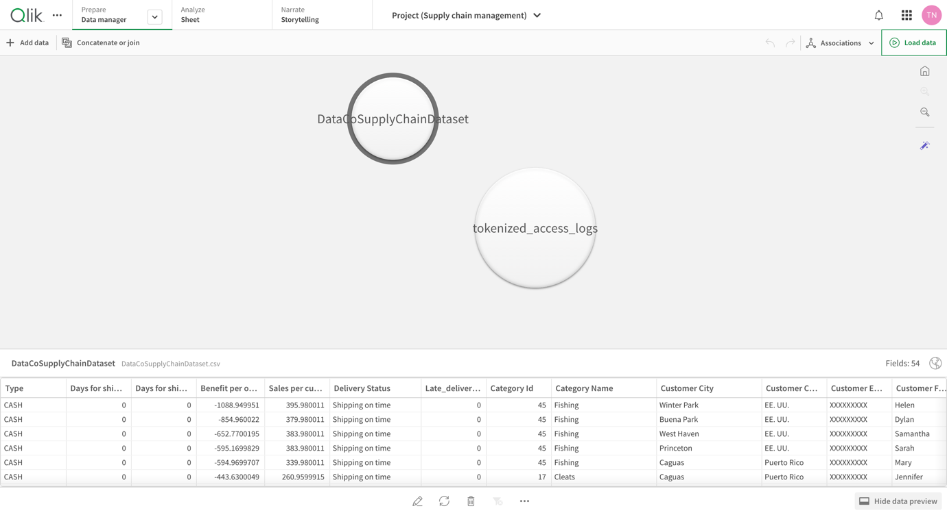

Data sets are employed for this project -

1. [DataCoSupplyChainDataset.csv(95.91 MB)](https://www.kaggle.com/datasets/shashwatwork/dataco-smart-supply-chain-for-big-data-analysis/data#:~:text=calendar_view_week-,DataCoSupplyChainDataset,-.csv) - Structure data
2. [tokenized_access_logs.csv(91 MB)](https://www.kaggle.com/datasets/shashwatwork/dataco-smart-supply-chain-for-big-data-analysis/data#:~:text=calendar_view_week-,tokenized_access_logs,-.csv) - Unstructured data

**DataCo Supply Chain Dataset:** This dataset likely contains information relevant to the DataCo company's supply chain operations. It includes data on orders, shipments, inventory levels, product information, supplier details etc. Here's a breakdown of the data fields present in the dataset.

* **Order Details:** It includes columns for order shipping days, benefit per order, and sales per customer, suggesting data on order processing times, profitability, and customer spending.
* **Delivery Status:** A column showing "Delivery Status" with options like "Shipping on time" and "Late delivery" indicates tracking of order fulfillment.
* **Customer Information:** Data on customer city, country, and potentially email addresses can be used for customer relationship management.
* **Product Information:** The "Category Name" and "Category Id" columns suggest data on product categories, which could be linked to a separate table with detailed product information.

This is just a glimpse based on a few columns. The dataset holds a wealth of information that can be used for various purposes such as:

* **Demand Forecasting:** Analyze historical sales data to predict future demand for products and optimize inventory levels.
* **Delivery Performance Analysis:** Track on-time delivery rates and identify areas for improvement in order fulfillment.
* **Customer Segmentation:** Group customers based on purchase history or location for targeted marketing campaigns.
* **Supplier Management:** Analyze data to assess supplier performance and identify cost-saving opportunities.

By effectively using this data, DataCo can gain valuable insights to improve their supply chain efficiency, customer satisfaction, and overall profitability.

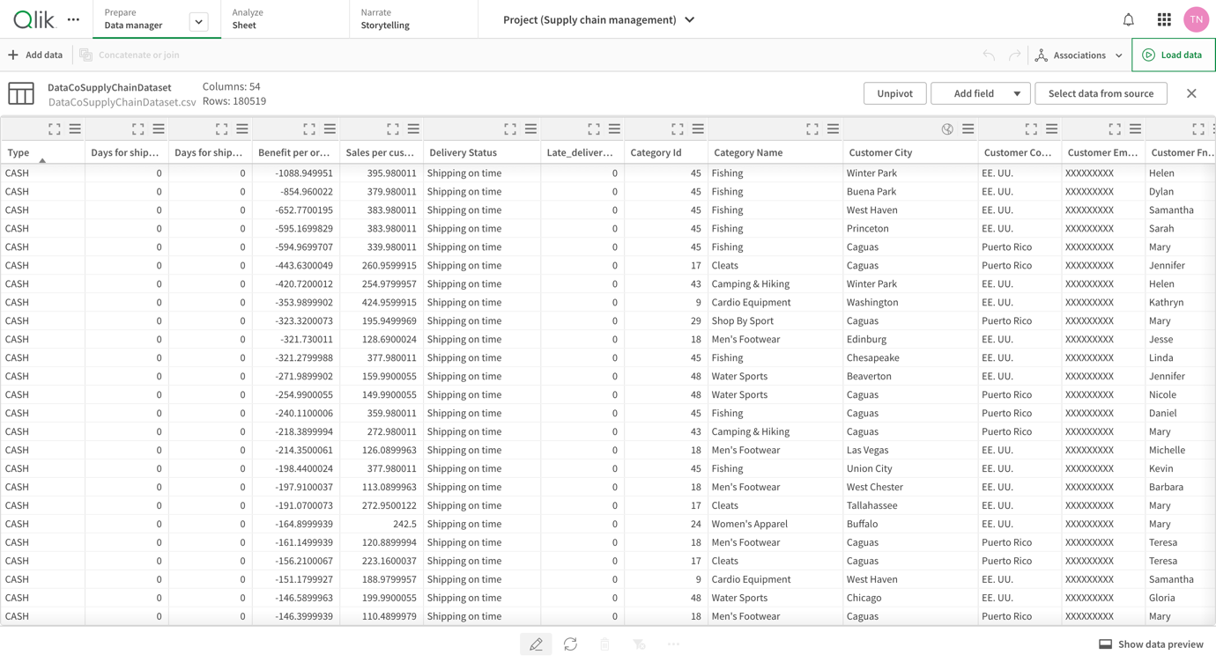

**Tokenized Access Logs:** This dataset is related to access logs, possibly from a server or application used in the DataCo supply chain. The access logs are likely tokenized, meaning sensitive information like usernames or passwords have been replaced with non-identifiable tokens. While the sensitive data is removed, this dataset could still be useful for security analysis.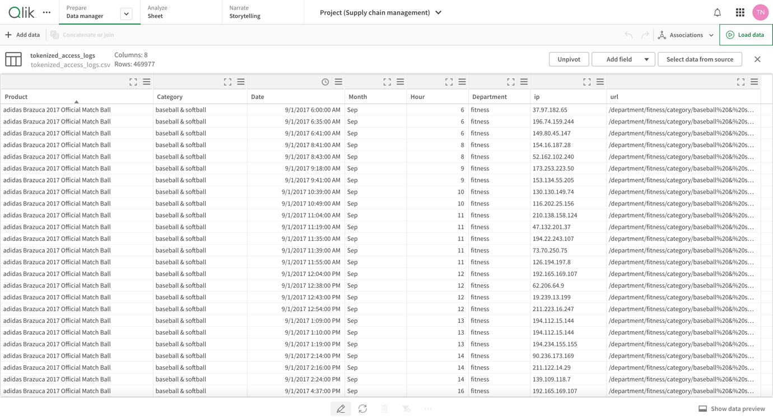

Here's a breakdown of what we can infer from this data view:

* **Data Fields:** The table likely includes columns containing various data fields related to user access, such as:
  + **Product:** This indicates the product or resource users were trying to access within the supply chain system.
  + **Category:** This categorizes the accessed product or resource (e.g., inventory data, order processing, shipment tracking).
  + **Date:** This would show the date and time of the access attempt.
  + **Month:** This is a separate column for the month of the access.
  + **Hour:** This shows the hour of the access attempt.
  + **Department:** This indicates the department or team associated with the access attempt.
  + **IP Address:** This would be the anonymized IP address of the device used to access the system.
  + **URL:** This likely contains a partially anonymized URL (due to tokenization) that specifies the specific resource or function accessed within the system (e.g., /department/fitness/category/baseball...).

**8.2 UTILISATION OF DATA FILTERS**

Utilization of Filters" refers to the application or use of filters within a system, software application, or data processing pipeline to selectively extract, manipulate, or analyze data based on specified criteria or conditions. Filters are used to narrow down the scope of data, focusing only on the relevant information that meets certain predefined criteria.

For example, let us Filter out the data using the 'order city' filter

Following Are the trends in data for Two different cities -

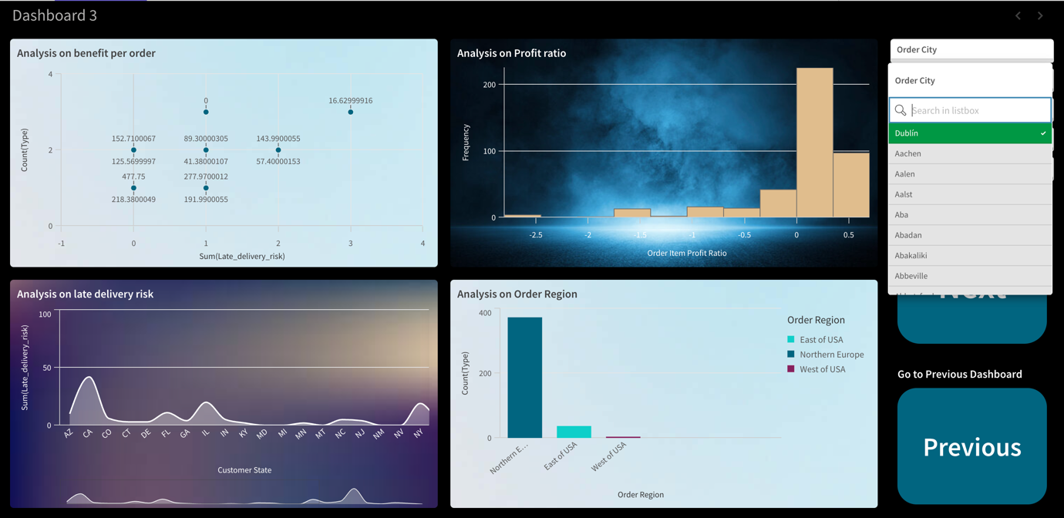

The filter is set to "Dublin", which adjusts all visualizations to show data specific to orders from Dublin.

* + **Analysis on Benefit per Order**: Displays a scatter plot showing the benefit per order against late delivery risk for Dublin.
  + **Analysis on Profit Ratio**: The bar chart visualizes the distribution of profit ratios for orders placed in Dublin. Clearly, Dublin faces Lower variation in profit ratios than London.
  + **Analysis on Late Delivery Risk**: The line graph indicates the late delivery risk summed by customer state, influenced by orders from Dublin.
  + **Analysis on Order Region**: Shows the count of orders by region, filtered to only display regions pertinent to Dublin orders.

When The filter is switched to "London", changing the data displayed in all visualizations to reflect orders from London,

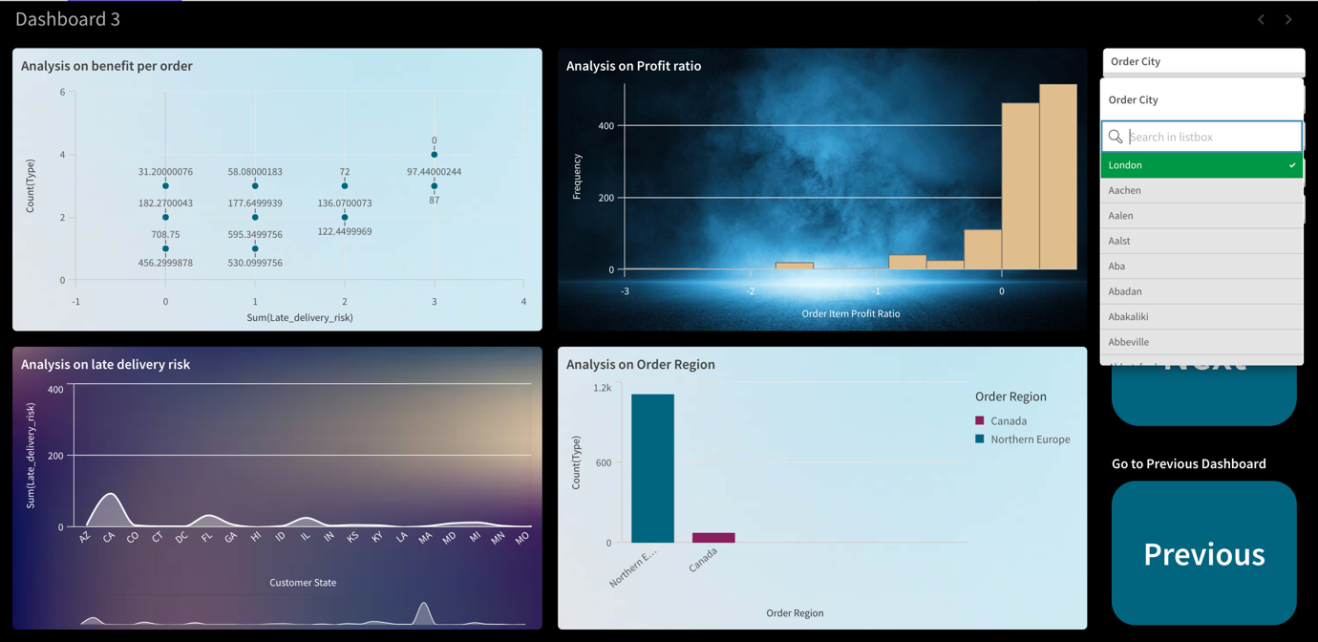

* **Analysis on Benefit per Order**: Updates the scatter plot to show the benefit per order against late delivery risk for London.
* **Analysis on Profit Ratio**: The bar chart now shows the distribution of profit ratios for orders placed in London.
* **Analysis on Late Delivery Risk**: The line graph is adjusted to indicate the late delivery risk summed by customer state for London orders. Clearly, there is less variation in delivery risk for London than Dublin.
* **Analysis on Order Region**: Reflects the count of orders by region, filtered for orders related to London.

**9.**   **CONCLUSION**

Using Qlik Sense in business analytics provides organizations with a robust tool for transforming raw data into actionable insights. The platform's advanced data visualization capabilities enable users to explore complex datasets with clarity and precision, making it easier to identify trends, uncover patterns, and drive informed decision-making.

The interactive and dynamic nature of Qlik Sense allows for real-time data analysis, which is crucial for responding swiftly to changing market conditions and business needs. By utilizing various filters, such as geographical and temporal dimensions, businesses can conduct highly targeted analyses, facilitating more accurate and relevant insights.

Qlik Sense's user-friendly interface and powerful analytical features empower all levels of an organization, from data analysts to executive decision-makers, to engage with data directly. This democratization of data analytics fosters a data-driven culture within the organization, encouraging continuous improvement and innovation.

In essence, Qlik Sense not only enhances the efficiency and effectiveness of business analytics but also supports strategic initiatives by providing clear, visual representations of critical business metrics. Its ability to integrate diverse data sources and deliver comprehensive, real-time insights makes it an invaluable asset for any organization aiming to leverage data for competitive advantage and sustained growth.

[